CKGSB (Europe) Ltd
11-12 St James’s Square, London, SW1Y 4LB, United Kingdom
Tel: +44 (0)20 7104 2380; VAT: 169 3450 86

China Start Program
China Start is a one-week immersion program for global Start-ups, growth companies and VCs to gain China-specific knowledge; connect with potential partners and customers; and pitch to investors in China.
Please complete this registration form, and email back with the following to Program Manager, Liping Wan at lpwan@ckgsb.edu.cn:

APPLICATION PACKAGE:
The CKGSB China Start Program Director will only review applications when they are complete. A completed application must include the following:
- A completed electronic application form in Word and signed copy in PDF
- Most up to date participant’s bio and company(ies) profiles
- Participant Professional Portrait/Headshot (High-resolution)
- Company Logo (High-resolution and transparent background)
- Your passports ID page (for visa invitation letters and intercity travel bookings)

Notes:
- The application form MUST be completed in English
- Your passport MUST be valid within 6 months and ensure your passport is in good condition(not worn out) and enough space to allow Chinese visa sticker to be put on your passport (Not full of stamps), in order to apply a Chinese visa at Embassy successfully.

- Please note the information provided in your application is strictly confidential. CKGSB Europe reserves the right to modify the program dates, location, and fee at any time.

PROGRAM DATE: Nov. 23 -27, 2020,
(3days in Beijing and 2 days in Shenzhen)

LOCATION: Beijing& Shenzhen

Application Deadline: Oct 15th, 2020
PROGRAM FEE (cross those apply):

Start-up/Growth Companies
£6,800 for the 1st participant (exc. VAT/ VAT free)

£3,500 for the 2nd participant from the same company

£3,500 for the 3rd participant from the same company

- Early birds discount 10%: accepted & enrolled prior to Oct 15th
- VC reps, institutions, banking and partners: £10,000 per person

PROGRAM FEE INCLUDES:
- Program tuition fee
- 5 nights’ hotel stay (4 stars and above)
- Domestic flights, and high speed train (economy class)
- Meals
- Teaching materials
- Company visits
- Taichi Lesson and outfit
- Program related local transportation, including airport transfer, company visits and pitch events transportation as a group

PORGRAM FEE DOES NOT INCLUDE:
- International return flights
- Visa application fee

THE ADMISSION PROCESS

1. Submit your application
Please start the application process as soon as you are certain of your intention to apply. Program Director will review your application and invitation decision will be made within a week time. If necessary, a call/meeting will be set up for the purpose of confirming if the program corresponds to your profile and business objectives.

2. Invitation Confirmation
Your Program Manager will confirm your attendance and you will receive an invoice of the program fee.

3. Payment to commit
Please pay the program fee 15 days from the invoice date and immediately if acceptance was received within 8 weeks of the commencement of the program. The program fee includes tuition, teaching materials and selected meals during the program.

Part 1 - Participant Information

Participant 1
Gender (Male/Female):
Title (Dr/Mr/Mrs/Ms):
Nationality (ies):
Date of birth (Day/Month/Year):
First name:
Middle name: (please refer to your passport)
Surname:
Company name:
Job title:
Country(Headquarter and branch office ):
Company Address: City:
Industry/ Sectors:
Company website:
Email address:
Mobile number:
WhatsApp ID:
WeChat ID(Please do create own ID and add Liping program manager on 286822337):
Company profile (Up to200 words):

Participants Biography (150-200 words);

(1) Describe your reasons for applying to China Start Program? What do you expect to gain from the program? (Eg. Gain Knowledge/Seek Funding/Business Partners or knowledge partners/Identify Customers)? (Up to 150 words)

(2)How do you foresee your business potentials and opportunities in China? If you have any future plan, please specify. (100-150 words)

Participant Photo (please Insert your professional headshot/ portrait here in high resloution and also attach that via email)

Please insert your company Logo here
Where did you hear about this program:
Require Chinese visa? Yes/ No
Do you need visa letter? Yes/ No
If so, please provide below passport info. (Please note your passport needs to be valid within 6 months to apply a Chinese visa and in good condition)
Preparation of visa invitation letter if applicable:
- First name:
- Middle name
- Surname:
- Date of Birth:
- Passport number:
- Date of passport issue:
- Date of expiry:
- Citizenship:
To travel agency and CKSGB staffs for your logistic arrangement:
Are you vegetarian? Any food allergy? (Please specify if you have any Dietary requirement/ restriction for your food)? If yes, please specify

Which do you prefer for 3Nod luncheon? Chicken/ Salmon Fish /Steak/Vegetable
Do you want the local travel agency to book your inner cities flights and hotels as a group, which are included the program cost? Yes/ No
If so, please insert your passport copy below for domestic flight bookings and hotel bookings:

Do you want to play Taichi in the morning and purchase the Tachi outfit?
Yes/No
If so, please let us know your height and weight to customize your Taichi outfit, or please use the below chat to let us your size:
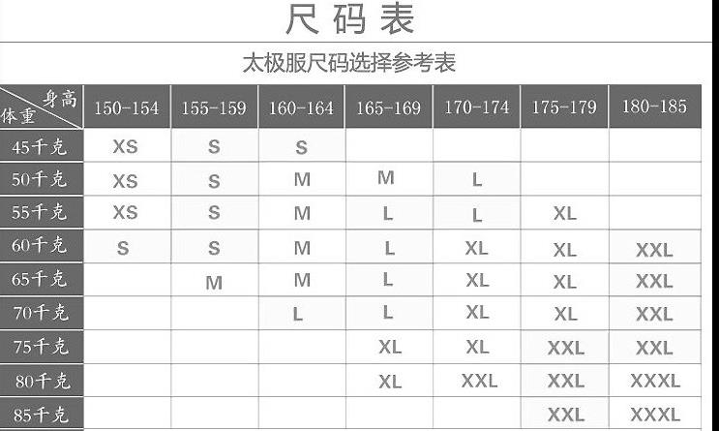
Your size/ Weight and Height?

Participant 2, if applicable, please copy the Participant 1 form above here and fill in your details.

Part 3: Billing details
Please indicate in whose name the invoice for the program fee should be issued, If different from part 1 above
- Individual Name:
- Company Name:
- Company Address:
Postal code _____________; City ____________; Country _____________
- Telephone number:
- Email address:
- VAT No. (If applicable):

PAYMENT BANK DETAILS
Once a place has been offered, to guarantee your space please make payment into the following bank account within 7 days from receiving an official email offer:
- Account name: Cheung Kong Graduate School of Business (Europe) Limited
- Account number: 61641131
- Sort code: 40-05-22
- Bank name: HSBC Bank PLC
- Bank address: 18A Curzon Street, Mayfair, London, W1J 7LA, UK
- IBAN: GB93HBUK40052261641131
- BIC/SWIFT: HBUKGB4107K
(Note: For bank transfers, please state reference as: China Start +Participant Name)

CANCELLATION AND TRANSFER POLICY
If you are admitted to the CKGSB China Start Program, but find that you are unable to attend, you must notify CKGSB in writing to either cancel or transfer to the next available session 2 month beforehand. In the case of cancellation, the program fees paid for program modules that have already started are non-refundable.

DECLARATION
1. I hereby declare that I wish to participate in the China Start program offered by CKGSB Europe Ltd. and will commit to attending during the dates of Nov. 23rd -27th, 2020. I have reached this decision of my own accord. I have the complete understanding of the program’s purpose and what I will gain from the program. I understand that my business is not guaranteed an investment and the benefits will be developed from my own contribution and engagement in the program.
2. I understand that the program fee does not include visa application fee and, insurance. I am aware that there is no refund offered by the school should cancellation take place less than two calendar months before the program.
3. I understand that changes to the program may occur and the program schedule is subjected to change, depending on the availability of resource, such as company visit arrangement. I am aware of participants responsible for their own visa, program fees will not be refunded even if they failed to obtain visa from Embassy. I am aware that CKGSB will ensure that this does not affect my overall experience of the program. Faculty, investors and alumni attendance may vary but all content of the program that was promised to me will be delivered.
4. I am aware of the conditions of admission to the CKGSB China Start program.
5. I am aware of the need for fluency and advanced writing skills in the English language, and of mandatory program attendance.
6. I am aware and agree to adhere to program requirements in a professional manner.
7. I have read, understood and accept the cancellation and transfer policy.
8. I certify that the information given in this application is complete and accurate to the best of my knowledge.
9. I confirm my private insurance provides coverage for medical care, illness and injury in China while attending the program.
10. I am aware that there is no refund offered by the school should cancellation take place less than 2 months before the start of the program, including failing to obtain a valid visa to travel.
11. I understand that changes to the program schedule may occur, depending on the availability of resources, such as company visit arrangement. I am aware that CKGSB will ensure that this does not affect my overall experience of the program.
12. I grant CKGSB, its agent or assignee the full discretionary right to use for marketing, PR and educational purposes, any audio-visual material in which I am featured (including my appearance, voice and any content) during my program at CKGSB. This includes, but is not limited to still pictures (photography), video and/or audio recordings made on campus or on the occasion of activities off-campus.

_____________________________

Signatory of applicants

______________________________

Date

To avoid disappointment, please return your completed application with supporting documents to your Program manager, Liping Wan, on email: lpwan@ckgsb.edu.cn

